WEB ENGINEERING

**HTML5 FEATURES**

Assignment 1

horizontal line

# 

Group BSCS 6A

* Arifullah Jan 186943
* Bilal Khalid 128608
* Saqib Shakeel 176783
* Waqas Yaseen 196819

# Introduction

HTML (Hypertext Markup Language) is used to build website layouts. Its provides the user interface for the website and to be more specific it just provides the structure of the website whose design is changed with CSS(Cascading Style Sheet) and it is behaviour can be changed with javascript.

So html was introduced by TIm Berners Lee the same person who invented www. It was supposed to be the format in which information will be shared across internet in www. But since 1990s the web has grown and progressed so much that the same old html could not fulfill the needs of time. So updates needed to be done so that the the web programmers could easily create amazing content because they won’t need to worry about the programming of the basic things, which so common. In other words to prevent reinventing the wheel. Also it was difficult for the user. It was good to have a common solution for all.

HTML5 was introduced by publically in 2008 and was adopted as a standard.

# Section 1: New Features in HTML5

In this section we will discuss the completely new tags and that were introduced in html.

To list some of them following are the the new features in html5 :

1. Video
2. Audio
3. Figure
4. Section
5. Nav
6. Header
7. Footer
8. Svg
9. Canvas

## 

## Video

Video element was introduced in html5. With this element one can easily include a video a web page.What this element actually does is that it embeds a media-player that allows video playback in our web page Before this to include a video the webpage needed to user third party plugins to include video files playable in browser. But now in html5 one can easily include a in browser playable video very easily.

|  |
| --- |
| <html>  <head></head>  <body>  <video width="400px" height="300px" controls="">   <source src="video-url.mp4" type="video/mp4"></source>   </video>  </body> </html> |

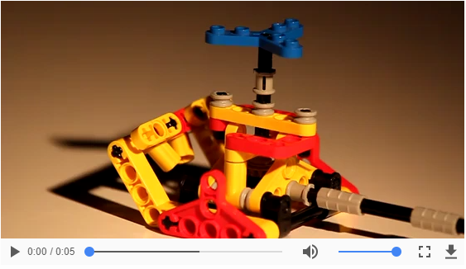

This video element can have any parent which allows the embedded content  
The **width** and **height** tags can be used to alter the dimensions of our video.  
**Crossorigin** tag determines whether to include Cross-Origin Resource Sharing (CORS) or not in our web page  
**Loop** is boolean attribute ,if turned the video will play again from the start after completing.  
**Control** is most important attribute of video element as it allows the user to handle the playback options such as changing the volume, seeking a specific part or pausing/resuming the video.  
**Playsinline** is a boolean attribute of video which specifies that our video will be played ‘inline’ which means inside the playback area for specified for the element.  
**Src** used to add the url of video to be embedded once can also make use of <source> inside the video block. **Muted** as the name express their function muted is boolean attribute which specifies the setting of audio.Muted the audio will have no sound initially its default value false  
Several other attributes attributes are also there such as **preload,played and poster** all these attributes provide the developer a wide control over video content and help to improve the user experience of web page.

## 2. Audio

One can make use of audio element to embed the sound to the document.Now one don't require a plugin as flash player for audio to be played in the browser.Many of the attributes of audio and video are same and have same functionality such as **control,preload,loop,muted,src** serve the same purpose for as explained in video section above

## 3. Figure

Figure element is used to add an picture,diagram or a code block to the document.It is referenced in main flow but we can move it to any portion of the page making the main flow safe from any effect.Sometimes it is used with conjunction with **<figcaption>** as the name suggest adding caption to the figure.

Before html5 there wasn't any feasible way of adding pictures with a caption to document like it is with <figure> and <figcaption>.It only make the use of global attributes and has no attributes of its own.

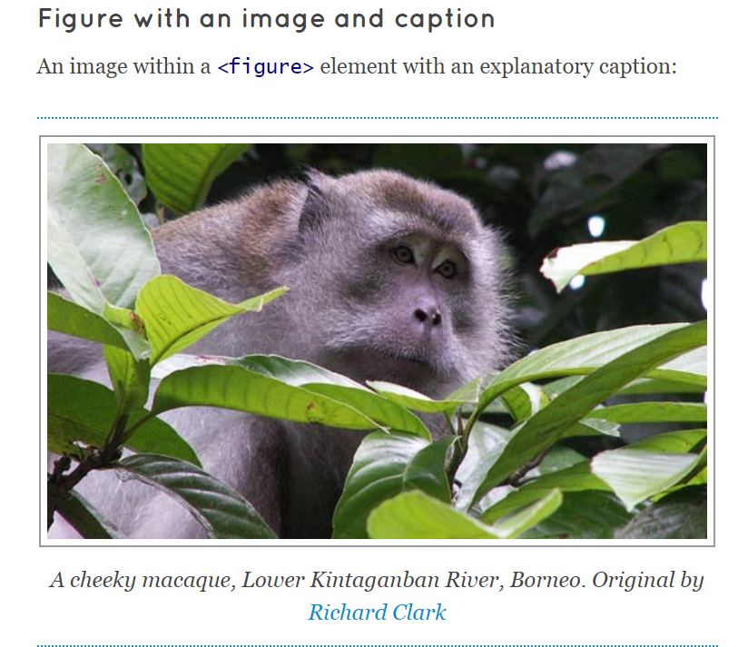

**Code for the figure is**

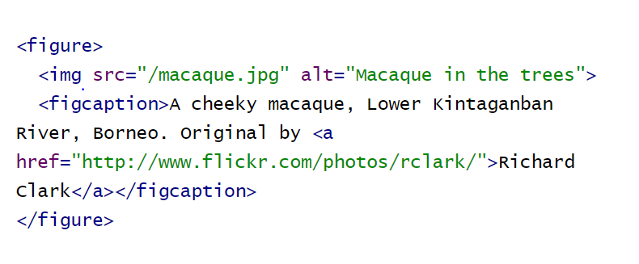

We can also add a figure element with multiple images inside it we can also use figure element to display the code snippets

## 4. Section

This tag is introduced in html5. Using the section tag we can generate different sections in our web page. Section are similar to divs to some extent. Sections can stand alone.

Mostly we use sections when we have different headings and we have to explain them in our web page.

|  |
| --- |
| <html>  <head></head>  <body>  <section>   <h1>WWF</h1>   <p>The World Wide Fund for Nature (WWF) is....</p>   </section>  </body> </html> |

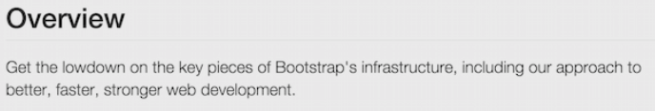

## 5. Nav

In html5 nav tag is introduced which was not supported by html4. Whenever we have to link a web page with different web pages we use this tag. It can also link different links within the same page. This tag is almost used in every website.

Menu bars, table of contents and indexes are some examples of navigation section.

|  |
| --- |
| <html>  <head></head>  <body>  <nav>   <p><a href="login.html">Log In</a></p>   <p><a href="signup.html">Sign Up</a></p>   <p><a href="contact.html">Contact Us</a></p>   </nav>  </body> </html> |

## 6. Header

Header tag is new in Html5. This tag basically creates a block or container at the very top of your web page or website. This block contains the introductory feature of the website,Like logos,links which may be contact us, about us also it may contain author’s information.

More than one header tags can be used within a page.header tag cannot be used within the other header tag, footer tag and address tag. Earlier versions of some browsers does’t support header tag.

**Sample Header:**



|  |
| --- |
| <html>  <head></head>  <body>  <header>   <img src="companies-logo.png" />   <nav>   <p><a href="about.html">about us</a></p>   <p><a href="facts.html">facts</a></p>   <p><a href="contact.html">Contact Us</a></p>   </nav>   </header>  </body> </html> |

## 7. Footer

This tag is new in html5. Footer tag creates a footer at the bottom of the webpage. This the footer contains basic information of the webpage which may includes copyright, contacts, map for the site, authorship and links to social media.

In a document more than one footer tags can be used.

## Sample Footer:

|  |
| --- |
| <html>  <head></head>  <body>  <footer>   <p>&copy; techjuice</p>  <p> </p>  <div class="social">   <a href="#"><img src="snapchat-icon.png" /></a>   <a href="#"><img src="twitter-icon.png" /></a>   </div>   </footer>  </body> </html> |



## 8. Svg

It is also new tag in html5. The term SVG is an acronym of scalable vector graphics. This tag basically defines the graphics for our web pages. By using this tag we can define different shapes of graphics. This tag is XML based.

It is independent of the resolution. More usable when large area is being used. In making games it is not that useful.

|  |
| --- |
| <html>  <head></head>  <body>  <svg width="90" height="80">   <circle cx="30" cy="40" r="50" stroke="red" stroke-width="5" fill="black" />   </svg>  </body> </html> |

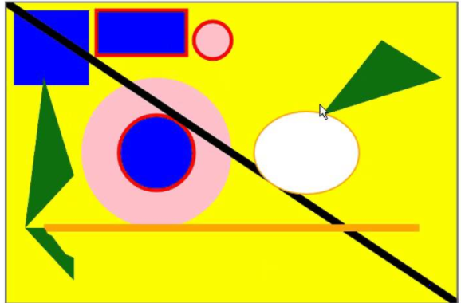

## 9.Canvas

This tag draws the graphics on our web page. Convas tag is basically a container in which we can draw graphics using javascript. Just like Svg we can draw different shapes of graphics using convas tag.

It totally depends on the resolution. For gaming Apps it is good. It doesn't includes the API.its rendering is done pixel by pixel.

|  |
| --- |
| <html>  <head></head>  <body>  <canvas id="myCanvas" width="100" height="150" style="border:2px solid #000FFF;">   </canvas>  </body> </html> |

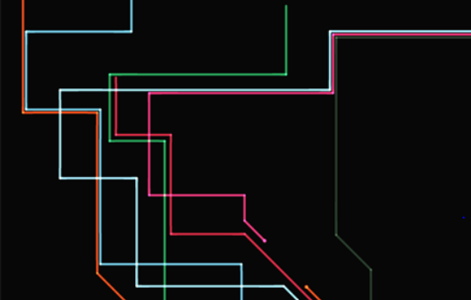

# Number, date, Time, Range and Calendar Elements

The above all elements are of type input. Whenever we need any of the above element we use input type tag in which further we have to specify which element we want to use.

## 

## Number:

In some cases we only need numbers as input like if we need CNIC of someone it will be obviously in form of numbers. In such cases we use the element Number.

|  |
| --- |
| <html>  <head></head>  <body>  <input id="number" type="number" />  </body> </html> |

It will generate a rectangular block in which we can only enter a number. .

We can add the option of increasing or decreasing the entered number one step or more which we desire on every single click. It will look like this.



## 

## Date:

This element is used whenever we want date as input. Which includes the format day/month/year. Also we can control the date using max and min tag. For example admission to a school is open they can control the date and fixed it to a limit which may be the last date of application.

|  |
| --- |
| <html>  <head></head>  <body>  <input id="date" type="date" />  </body> </html> |





**Time:**

For the time as input we use the input type time. The display of the time field is different in different browsers. Some give you option of selecting the time and in some you have to write manually by yourself.

|  |
| --- |
| <html>  <head></head>  <body>  <input id="time" type="time" />  </body> </html> |



**Note:** DateTime format is obsolete now in most of the browsers.

**Range:**

In our input type we use the element of range when we need a fixed value of the range. For example to control the volume or brightness of our laptop we must have a specific value against that selected range.also we can control the range by using min and max.





|  |
| --- |
| <html>  <head></head>  <body>  <input type="range" />  </body> </html> |

# Section 2:COMPARISON BETWEEN HTML4 & HTML5:

**WHAT LED TO THE DEVELOPMENT OF HTML5:**

HTML4 was developed by tim berner lee in the year 1990 and it is the oldest version of html which is still in use.

The drawback with HTML4 is which led to the development of the newer and the latest versions is that HTML4 has a very loose syntax. Loose syntax means that many important things in the latest versions of html are optional in HTML4. As an example, Closing tags of are most often optional in HTML4 ,e.g whenever a new paragraph is started in html 4 the older one is closed automatically i.e the paragraph does not have to be closed with a closing tag in HTML4. In the same manner there are many things optional in html4.

One main advantage of HTML4 in early days was that this property of loose syntax made HTML4 very easier for beginners to adapt to. Amateurs who did not have a very strong command on html would not have to worry about the closing tags even if they forgot to put them anywhere in there document.

But the main disadvantage with loose syntax is that you cannot achieve consistency with loose syntax across many browsers that we have nowadays. In the beginning html4 was a good option where there were not so many browsers as we have now. But now that we have so many browsers each browser would read the document written in html4 with loose syntax differently. And thus different browsers show us different results for the same html 4 document. Some browsers have the ability to read a closing tag even if it is not there while some latest browsers does not have this property. This makes HTML4 not so efficient for professional use.

To counter the loose syntax of html4 Xhtml was introduced. While we term html4 as an older version of the html, many old sites are still built on html.

For more than 10 years html 4 has been standard web development language.HTML4 is approved by W3C as a standard language for browsers.(W3C is an organization for approving standards for technologies of the web).

But with the rise of the smartphones era things have completely changed which has revolutionized the way in which many websites are established. In the early days web developers would target only desktop PCs and laptops while developing a website. While nowadays web-developer must think about the smartphone version of the website too. This concern is growing proportionally as smartphones users are increasing day by day. Now a web-developer must keep in mind how to develop a single website efficiently which could be use on desktop pcs, laptops and smartphones all at the same time. For this purpose HTML4 seems to lack certain features.

Although, W3C standard for web-browser applications is still HTML4, it does not adapt to the ever changing and revolutionizing trends of the computing Industry.

That’s why HTML5 has been developed in order to cope with these new challenges in the web industry.HTML5 is more flexible, as well as more advanced as compare to the older versions of the HTML.

# Removed/Obsolete Tags and Feature and their replacements in HTML5

**Acronym**:This was used to determine the character sequence to develop an acronym or abbreviation  
Now this is replaced by **<abbr>** in HTML5

**Applet**:This was used to embed java applet in the web page now this feature is replaced by another element **<object>**

**Basefont:**This element was used to determine the default settings for the font face ,size and its color this feature may still supported in some browser but the recommended option is using the **CSS** features of font,font-size,font-family and color.

**Big:**The big element was used to make the text of bigger size it is also replaced by the CSS properties

**Center:** It was used to align the element within the block to the center of it.The feature became obsolete in HTML4 because of **CSS**  
**Text-align ,margin-left** and **margin-righ**t which can be used to align the element to center

**Strike**: Was used to put horizontal line on the text now in HTML5 we can make use of **<del>** for the deleted content or we can **<s>** for some similar purpose

**Frame and frameset:** Frame was used to determine a particular area for the document and frameset was used to hold the **<frame>** elements both these elements are removed now the developers make the use of the **<iframe>**

Many of the features are removed in HTML5 because of wide range of functionality of **CSS**

**Many attributes are also removed some from elements as from**

**Object:**  
*Archive, border, classid, codebase, codetype, data, declare ,standby   
Tabindex* are obsolete now

**Body:**  
In body element the attributes like alink, background, bgcolor, text, vlink, bottommargin, link are obsolete now

Many other attributes such as valign, width, rules, nowrap, noshade, vspace, hspace, frameborder, compact are also removed from different elements

**Conclusion:**

Although many of attributes and tags are removed but they have a better replacement in HTML5 so HTML5 provide much more interesting and developer friendly functionality and helps developers to easily make what they want give a better appearance of the document of their users